IVAN GASTELU NINALAYA
Lima - Perú
+51992621622
gastelu.n.ivan@gmail.com
https://gasteluivan.github.io

SUMMARY
Hi, I am Ivan Gastelu Ninalaya, and I would like to introduce myself as someone who is always willing to learn and grow, both personally and professionally. I am a committed, passionate, and responsible person, with a goal-oriented focus and an open mindset towards new challenges and opportunities.
My work experience has allowed me to develop skills such as teamwork, adaptability to changing environments, problem-solving, organization, and deadline management. Additionally, I consider myself a creative and initiative person who is always searching for new ideas and ways of doing things.
Regarding my academic background, I have a solid foundation as a web, application, and video game developer, which has contributed to my personal and professional development.
In my free time, I enjoy researching new technology, which has allowed me to maintain balance in my life and develop skills and values such as discipline, perseverance, and creativity.
I am confident that my positive attitude and commitment to work will allow me to effectively contribute to any project or team in which I participate. Thank you for your time and consideration, and I look forward to any opportunities that may arise.

KNOWLEDGE

Software
- Database: MySQL, María DB, Firebase, MongoDB
- Platforms: Windows, Mac, Linux
- Programming languages: C#, JavaScript, PHP, Dart
- Frameworks: WordPress, Joomla, React, Flutter, Phaser 3, Vue JS, Reveal JS, CodeIgniter, Laravel
- Others: Webpack, HTML5, CSS, SASS, PUG, C4D, 3D Max, Unity 3D, Adobe XD, Animate CC, Dragon Bones, Rive, SVGator, WebGl, Tree JS, Illustrator, Photoshop, InDesign, Premier-Pro, After Effects, MS Office, computer repair and maintenance.

Languages
- English (Intermediate B+)
- Spanish (Native language)

EXPERIENCE
Analyst and Digital Area Manager | 2015 – 2022
FACTORIA MEDIA ESTUDIO (Lima – Perú)
- Video Game Development,
- APP’s, (AR, Story tales)
- Platforms E-learning,
- Responsive Web
- Interactive courses - E-learning
- Animated and interactive stories
Analyst Programmer Animator | 2012 - 2014
KRAKEN DESIGN (LIMA – PERÚ)
- Character and scenario animations in Adobe Flash
- Interaction development and scenario layout in ActionScript 2 and 3
- 2D and 3D character and scene design

Security and customer service | 2008 - 2009
Ocean Club Community Association, INC (Miami – Florida)
- Front Desk security - Lake Tower electronic building security control and management.
- Administration and control of entry of residents' visits to the tower.

Valet Parking Attendant | 2007 - 2008
Grand Bay Club - Torre II (Miami – Florida)
- Reception, care and parking of all types of automobiles.

Ornamental Plants Care and Maintenance | 2006 - 2007
Nursery – Homestead (Miami – Florida)
- Care and sprayer for chemicals.

Livestock Worker Ranch Hand | 2004 - 2006
Cross Mountain Ranch (Craig – Colorado)
- Handling of heavy machinery for planting and harvesting grass in summer.
- Cattle sanitary and reproductive management
- Care, feeding and fattening of cattle

Electronics trainee repair of electronic equipment | 2002 - 2003
Electrónica Ruttie - (Lima – Perú)
- Repairs of electronic equipment TV, Radios, etc.

EDUCATION
TOLOUSE LAUTREC  Santiago de Surco – Lima Perú  - Web and Multimedia Designer | 2010 - 2013

SENSICO  Huancayo Junín – Lima Perú  - Graphic design and Web development | 2000 - 2001

SENATI  Huancayo Junín – Lima Perú  - Web and Multimedia Developer | 1999 - 2000

GAMOR CETPRO  Cercado de Lima – Perú  - Electronics - Repair of electronic equipment. | 1998 - 1999

DOCUMENTATION

Toulouse Lautrec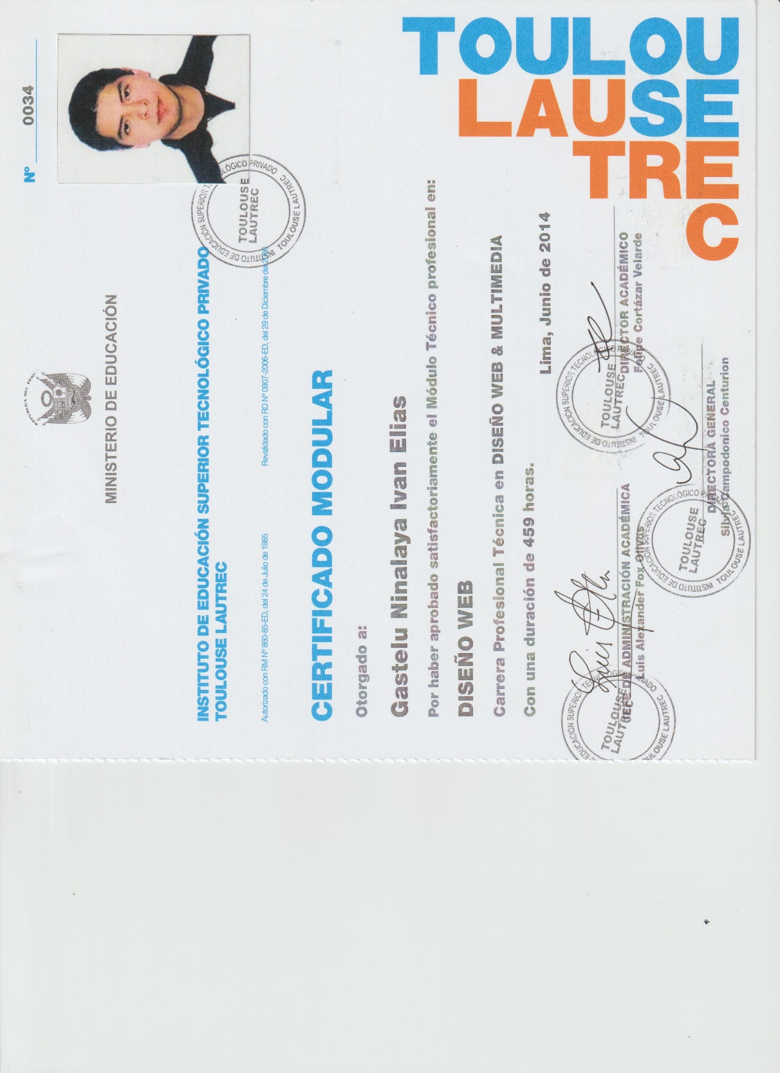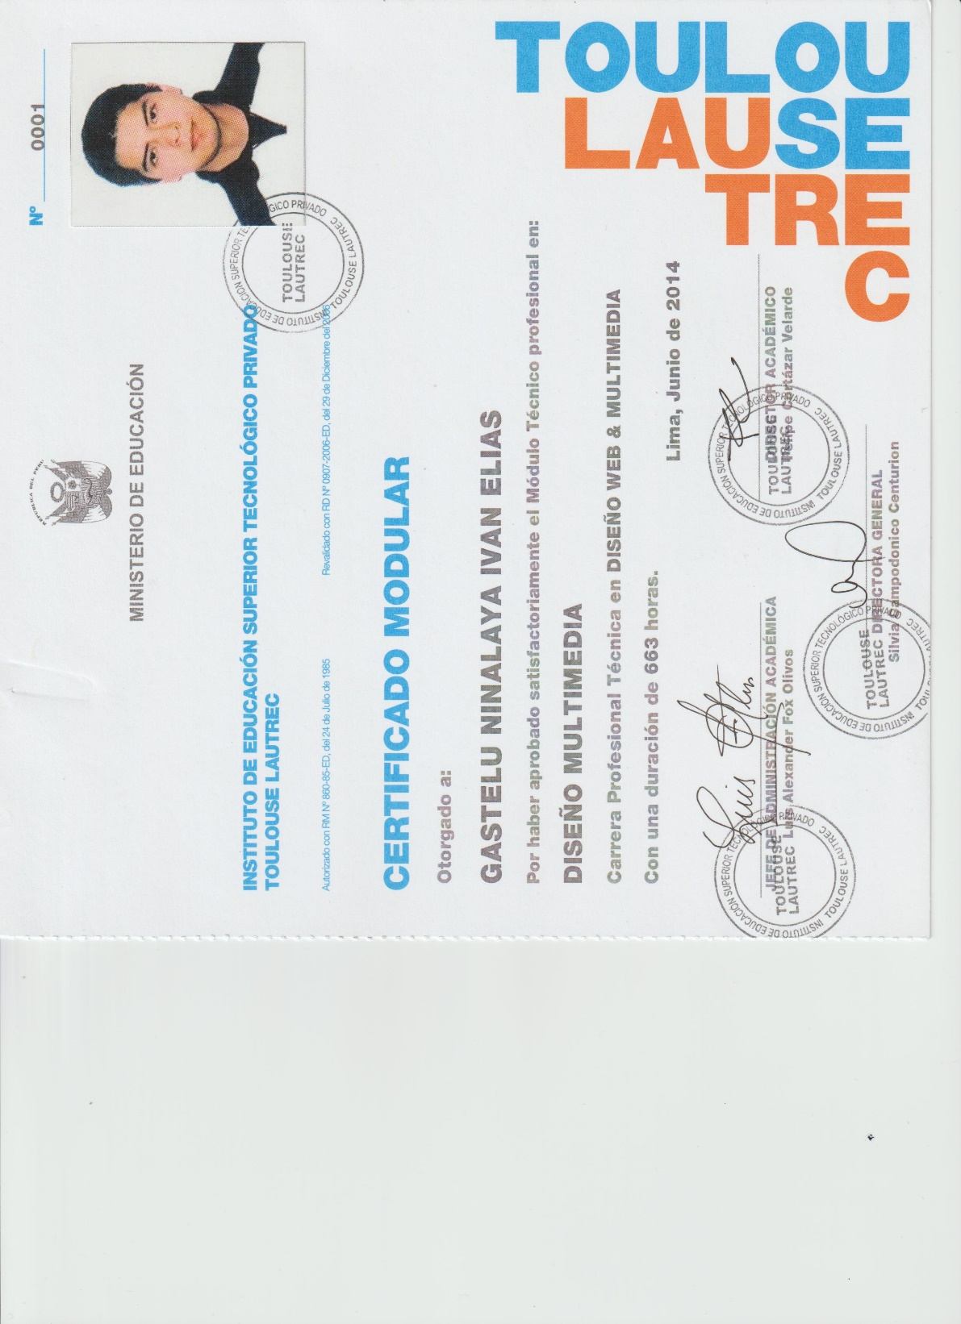

SENSICO
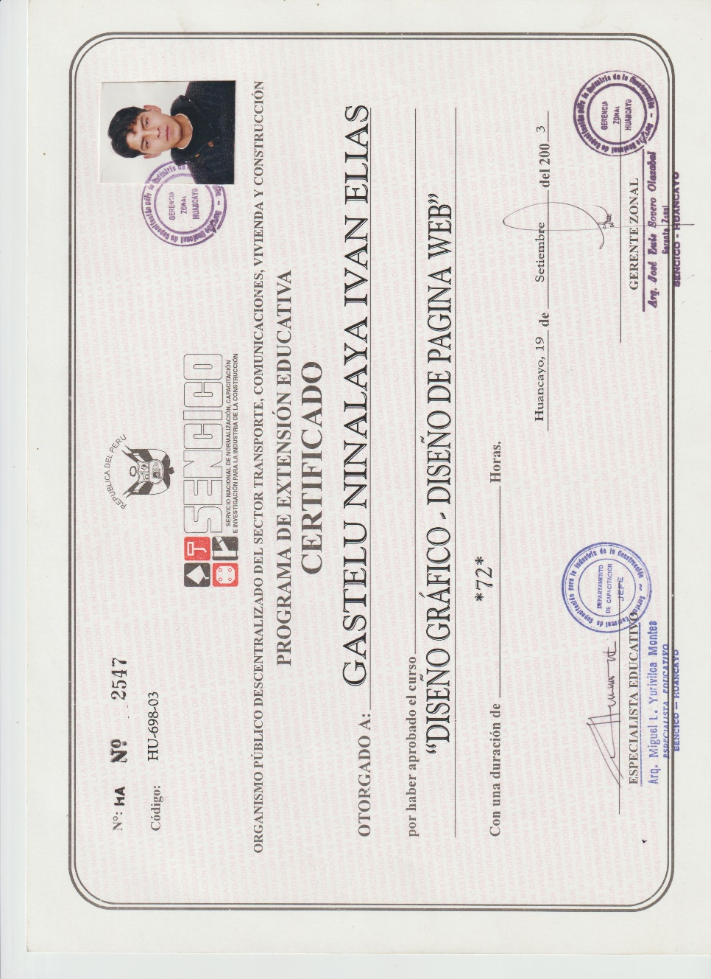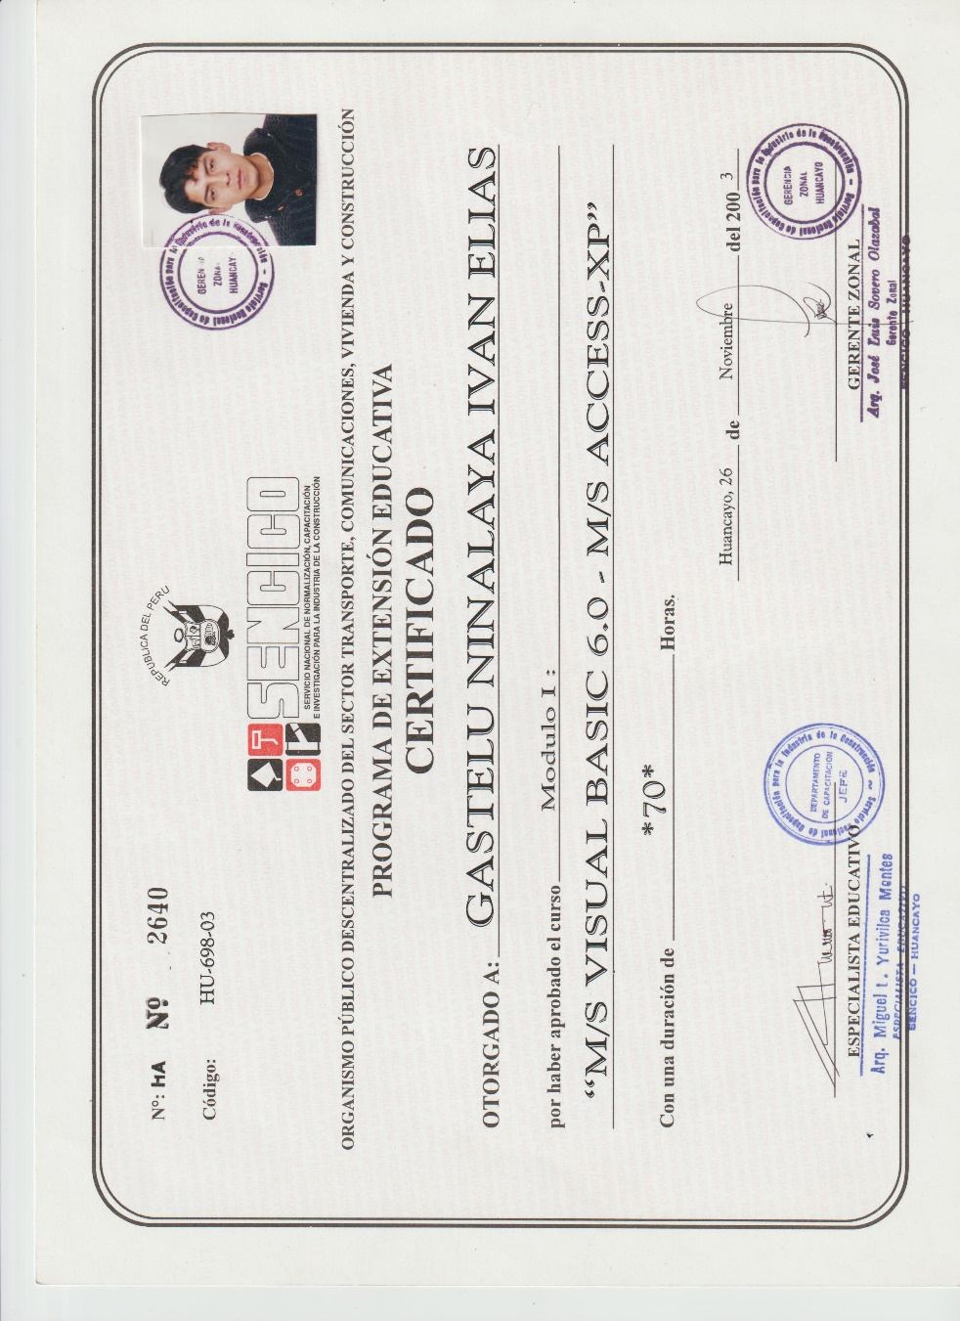

SENATI

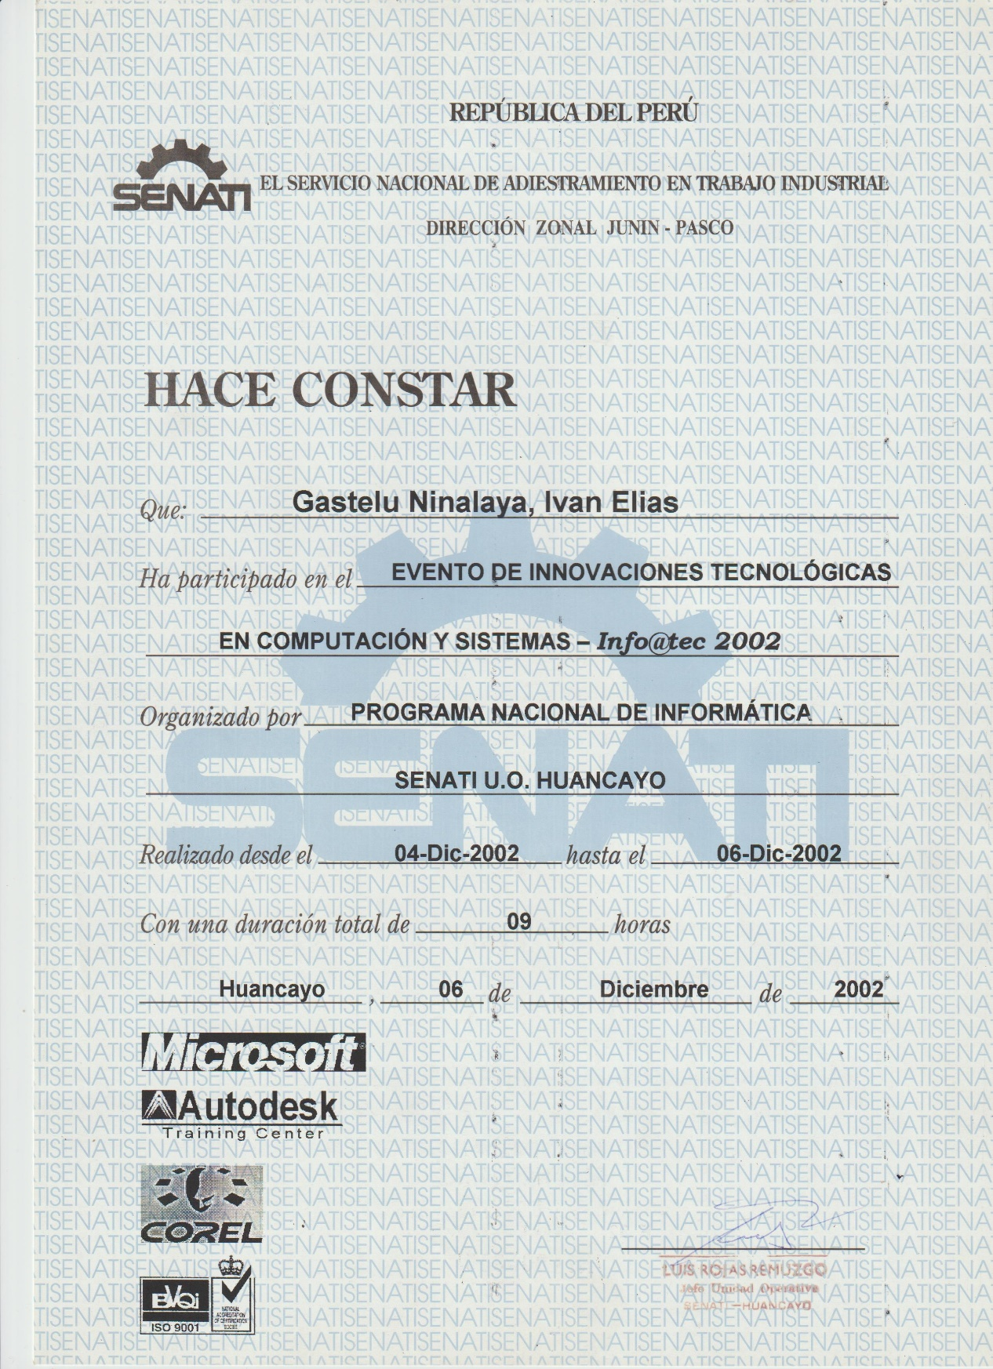

GAMOR


OTROS
